DETECTING AI GENERATED IMAGES WITH CNN AND INTERPRETATION USING EXPLAINABLE AI
Methodology, Novelty and Key Contributions
Department of Computer Science and Engineering, [COLLEGE NAME]
Batch C14 (CSE-C) · Academic year [ACADEMIC YEAR]
Table 1: Project team
S.No. | Student name | Roll number
1 | Ponugoti Viduranandan | 23K91A05J5
2 | Naina Baherji | 23K91A05G9
3 | Likki Pranathi | 23K91A05D2
4 | Motasani Sathish | 23K91A05G0

Project guide: M Thanmayee
Chapter and section numbers quoted in the text (for example Chapter 8 or Section 6.2) refer to the full project report, 17.Final Document. Figures and tables in this document are numbered from 1.

1. METHODOLOGY
This document describes how VeriVision AI works from end to end and what is new in it. Part 1 gives the pipeline, the data, the algorithms and the reasons they were chosen; Part 2 sets the work against the base paper and separates what is new from what is standard; Part 3 lists the contributions.

1.1 Overall Methodology
The methodology has two halves: an offline half that builds the four detectors and measures them, and an online half that serves one image at a time. The offline half takes a class-balanced subset of a public benchmark, fine-tunes four ImageNet-pretrained CNNs with different augmentation, loss and resolution, and evaluates each route and the fused ensemble on a held-out test set, on degraded copies of it and on a probe set from other sources. The online half validates an upload, runs the four routes, fuses their logits, explains the verdict with Grad-CAM and re-tests the image under three degradations. The stages are:
1. Data preparation. A class-balanced CIFAKE subset is written to train, validation and test folders; a cross-domain probe set is prepared separately.
2. Preprocessing and augmentation. Each route has its own training augmentation and a common evaluation transform (resize and ImageNet normalisation).
3. Route training. Four routes are fine-tuned from ImageNet weights with AdamW, cosine decay and early stopping on the validation F1.
4. Evaluation. Per-route and ensemble metrics, fusion ablations, a threshold sweep, bootstrap intervals, calibration, robustness and cross-domain tests are computed from cached logits.
5. Deployment. The checkpoints, a metadata file and the metric artifacts are written where the Flask service reads them.
6. Inference and explanation. For each upload: four route logits, fusion with two gates, a verdict with a confidence word, three Grad-CAM overlays and a robustness consistency score.

1.2 Dataset
The data are drawn from CIFAKE [8], a benchmark of 60,000 real images taken from CIFAR-10 [9] and 60,000 synthetic images generated with Stable Diffusion v1.4 [10], all 32 x 32 pixels, with an official split of 100,000 training and 20,000 test images. The copy used here is the Hugging Face mirror dragonintelligence/CIFAKE-image-dataset (parquet, JPEG, mirror labels 0 = FAKE and 1 = REAL; the dataset card has no licence field, while the Kaggle original and other copies are tagged MIT). The labels are remapped to the product's convention, 0 = REAL and 1 = AI_GENERATED.
The full dataset was not used, because the models are trained on a CPU. A class-balanced subset was drawn with seed 42: 3,000 real and 3,000 generated images for training and 600 of each for validation, both from the official training split and without overlap, and 1,000 of each for testing, from the official test split only. The test set therefore never overlaps with training, but the training subset is only 6 % of the official training split and the test set is 10 % of the official test split, and every conclusion about accuracy carries that limit.
Table 2: Data splits used in this project
Set | Source | Real | AI-generated | Total | Used for
Train | CIFAKE official train split | 3,000 | 3,000 | 6,000 | Fine-tuning the four routes
Validation | CIFAKE official train split (no overlap) | 600 | 600 | 1,200 | Early stopping, best checkpoint
Test | CIFAKE official test split | 1,000 | 1,000 | 2,000 | All reported metrics, ablations, threshold sweep
Robustness subset | First 500 per class of the test set | 500 | 500 | 1,000 | JPEG, resize, blur and noise tests
Cross-domain probe | Hugging Face Parveshiiii/AI-vs-Real (MIT) | 300 | 300 | 600 | Transfer to other photographs and generators

The cross-domain probe uses 300 real photographs of about 640 pixels and 300 generated images of 1,024 x 1,024 pixels, re-saved as JPEG at quality 95. The dataset card does not name the generators, so the probe measures transfer to some unseen generator and content domain, not to a specific model. Before this run the shipped models had been trained on deterministic synthetic demo images (500 / 100 / 100 per class); that data was replaced and is kept only as a backup.
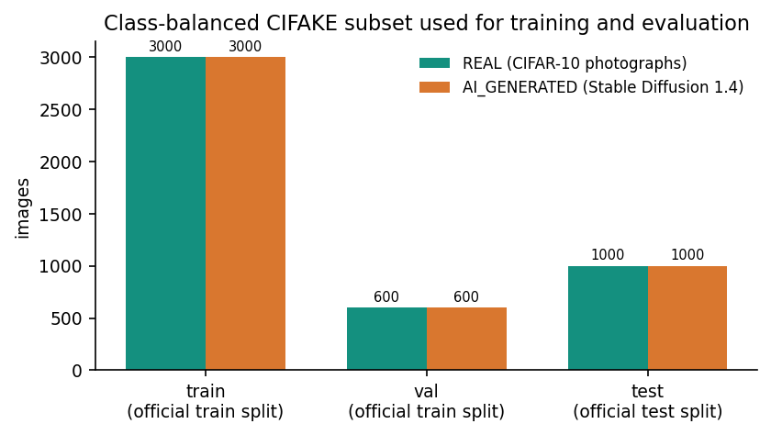
Figure 1: Class counts of the train, validation, test, robustness and cross-domain sets.

1.3 Preprocessing and Augmentation
At inference time every route uses the same transform: the image is converted to RGB, resized with bilinear interpolation to the route's square input size (224 x 224 for A1, A2 and C, 320 x 320 for B) without keeping the aspect ratio, converted to a tensor and normalised with the ImageNet mean (0.485, 0.456, 0.406) and standard deviation (0.229, 0.224, 0.225) [24]. CIFAKE images are 32 x 32, so they are enlarged by a factor of 7 or 10; the networks therefore see smooth, up-sampled pictures, which matters for the results in Chapter 8.
Training uses a different augmentation for each route, so that the routes learn different invariances. Route A1 uses the mildest, A2 the strongest, which imitates the degradations of social-media sharing, and B and C a moderate mixture.
Table 3: Training augmentation per route (scripts/common.py)
Route | Augmentation
A1 | Random resized crop (scale 0.8-1.0), horizontal flip, colour jitter (brightness 0.15, contrast 0.15, saturation 0.1)
A2 | Random resized crop (0.6-1.0), flip, rotation up to 12 degrees, colour jitter (0.3, 0.3, 0.2, hue 0.05), Gaussian blur (3 x 3, sigma 0.1-1.5), Gaussian noise (std 3-12, p 0.4), JPEG (quality 40-90, p 0.5), down-up resize (scale 0.4-0.8, p 0.4)
B and C | Random resized crop (0.75-1.0), flip, rotation up to 8 degrees, colour jitter (0.2, 0.2, 0.15), Gaussian blur (3 x 3, sigma 0.1-1.2), JPEG (quality 50-95, p 0.35)

1.4 Algorithm Choice and Justification
Convolutional networks with transfer learning. Generated images leave local statistical traces, and convolutional networks learn such traces directly from pixels. Fine-tuning ImageNet-pretrained backbones is the practical choice on a CPU: only the upper blocks are trained, which keeps training to minutes per route. The backbones are EfficientNet-B0 [19], ResNet50 [20] and MobileNetV3-Large [21]; they differ in design (compound-scaled mobile blocks, residual blocks, neural-architecture-searched blocks), which gives the ensemble different error patterns.
Heterogeneous ensemble with logit fusion and gates. The design follows HEDGE [2], which fuses three routes in logit space and adds two gating rules, but replaces its large foundation-model backbones (DINOv3 and MetaCLIP2, trained on eight H800 GPUs) with small CNNs. Fusing logits keeps the strength of each route's evidence, which a majority vote throws away and a probability average compresses. The gates are cheap deterministic rules that need no training data. Chapter 8 tests each of these choices on the same logits instead of assuming them.
Grad-CAM for explanation. Grad-CAM [26] produces a class-specific heat map for any CNN from the gradients of the output with respect to the last convolutional feature map, without retraining or changing the architecture. It was chosen because the project goal is an interpretable verdict and because the batch's own abstract names it. It is an explanation aid: a heat map shows where the gradient signal is strong, not a proof that those pixels are manufactured.
Relation to the base paper. The batch's base paper, CTrue [1], is a one-class face-deepfake detector that trains only on authentic faces plus synthesised pseudo-fakes, on an EfficientNet-B4 backbone with a hybrid-curvature representation. This project does not implement it. It addresses general images, trains a supervised binary classifier and adds an explanation and a deployed interface; the comparison in Chapter 8 states where the two differ.

1.5 Mathematical Formulation
Let z_k = (z_k,real, z_k,fake) be the raw logit pair of route k (A1, A2, B or C), w_k its weight (normalised to sum to 1), and d_k = argmax z_k its predicted direction (0 = REAL, 1 = AI_GENERATED). The margin of a route is the absolute difference of its two logits.
m_k = | z_k,fake - z_k,real | (1)
Gate 1 removes Route B when it is a confident outlier: B's margin reaches tau_B = 2.5 and every one of the other three routes points to the other class. The remaining weights are renormalised.
exclude B if m_B >= tau_B and d_k != d_B for each of A1, A2, C (2)
The fused logits are the weighted sum over the active routes, and Gate 2 then checks the consensus of B and C.
z_fused = sum_k w_k * z_k (over active routes) (3)
Gate 2 applies when B and C agree on a class c, both margins reach tau_B and tau_C = 2.5, and the fused direction is the other class. With delta = 0.75, the logit of class c is raised by delta and the other logit is lowered by delta / 2.
z_fused,c += delta ; z_fused,other -= delta / 2 if d_B = d_C != d_fused, m_B >= tau_B, m_C >= tau_C (4)
The probabilities and the verdict follow from a softmax. The confidence is the larger probability, reported as High when it is at least 0.85, Moderate when it is at least 0.6 and Low below that.
p_c = exp(z_c) / (exp(z_real) + exp(z_fake)) ; verdict = argmax p ; confidence = max p (5)
Route C is trained with the focal loss [22], which down-weights examples that are already classified well. With p_t the probability of the true class and gamma = 2:
FL(p_t) = (1 - p_t)^gamma * ( - log p_t ) (6)
Grad-CAM weights each feature map A^k of the target layer by the average gradient of the class score y^c and keeps only the positive evidence:
alpha_k^c = (1 / Z) * sum_i sum_j dy^c / dA^k_ij ; L^c = ReLU( sum_k alpha_k^c * A^k ) (7)
The evaluation uses accuracy, precision, recall, F1, balanced accuracy and the area under the ROC curve (AUC), computed with scikit-learn [29]. The expected calibration error (ECE) [25] bins the winning-class probability into 15 equal bins between 0.5 and 1 and averages the gap between accuracy and confidence, weighted by bin size. Accuracy intervals are 95 % percentile bootstrap intervals from 2,000 resamples of the test set [31].
ECE = sum_b ( n_b / n ) * | acc_b - conf_b | (8)

1.6 Model Architecture and Training
All four routes replace the ImageNet classifier by a two-class head. A1 and A2 use EfficientNet-B0 with dropout 0.3 and a linear layer; B uses ResNet50 with a linear layer; C uses MobileNetV3-Large with a 1,280-unit hidden layer, Hard-Swish and dropout 0.2. Only the upper blocks are fine-tuned and the rest stay frozen at their ImageNet values, which is why the trainable parameter counts are much smaller than the totals.
Table 4: Routes and training configuration
 | A1 | A2 | B | C
Backbone | EfficientNet-B0 | EfficientNet-B0 | ResNet50 | MobileNetV3-Large
Input size | 224 | 224 | 320 (+ flip TTA) | 224
Loss | Cross-entropy | Cross-entropy | Cross-entropy | Focal, gamma 2
Fine-tuned blocks | features 7-8, head | features 6-8, head | layer4, fc | features 15-16, head
Trainable / total parameters | 1,131,954 / 4,010,110 | 3,158,302 / 4,010,110 | 14,968,834 / 23,512,130 | 2,185,522 / 4,204,594
Learning rate / batch | 3e-4 / 32 | 3e-4 / 32 | 2e-4 / 16 | 3e-4 / 32
Planned epochs / seed | 5 / 42 | 5 / 43 | 3 / 44 | 5 / 45
Epochs run / best epoch | 5 / 5 | 5 / 5 | 3 / 2 | 5 / 5
Best validation accuracy / F1 | 0.9258 / 0.9270 | 0.8983 / 0.9047 | 0.8775 / 0.8902 | 0.9058 / 0.9110
Training time (CPU, upper bound) | about 24 min | about 22 min | about 53 min | about 13 min

All routes use AdamW [23] with weight decay 1e-4, a cosine-annealing learning-rate schedule over the planned epochs, and early stopping on the validation F1 with a patience of three epochs; the checkpoint with the best validation F1 is kept. Seeds are fixed for Python, NumPy and PyTorch. Training ran on the CPU of the development machine (Intel Core i5-12500, 6 cores / 12 threads, 15.7 GB of memory, no GPU) with PyTorch [28] 2.14.1. The times are wall-clock times from file timestamps on a PC that was shared with other jobs, so they are upper bounds. Route B, the most expensive, was planned for only 3 epochs; its best validation F1 came at epoch 2 and that checkpoint was kept.
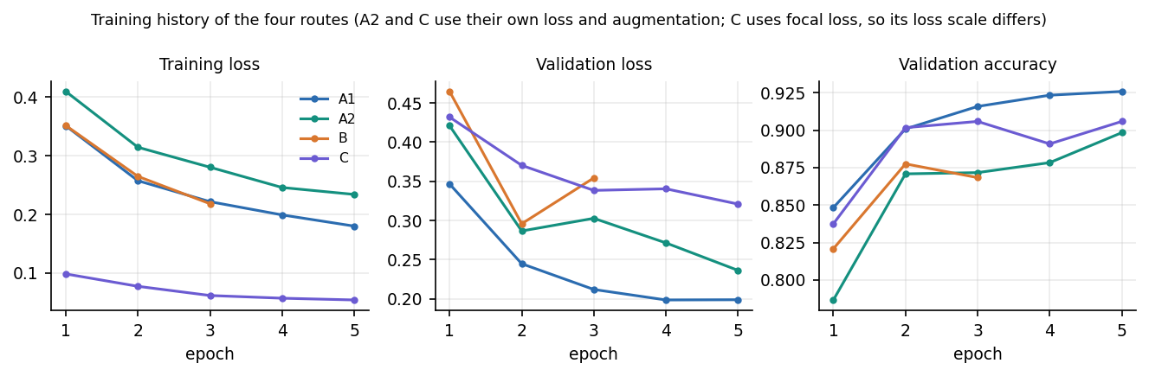
Figure 2: Training and validation curves of the four routes.

1.7 Evaluation Protocol
The evaluation was designed so that every reported number can be recomputed. The four routes are run once over each evaluation set and the raw logits are cached; every later analysis (the fusion variants, the threshold sweep, the intervals and the calibration) is computed from those cached logits, so that the variants differ only in the fusion rule and not in the model outputs. Route B is evaluated with the same horizontal-flip averaging that the application uses.
Table 5: Experiments run on the cached logits
Experiment | Data | What it answers
Clean evaluation | 2,000 test images | Accuracy, precision, recall, F1, balanced accuracy, AUC and confusion matrix of each route and of the deployed ensemble
Fusion ablation | Same logits | Do the weights and the two gates help? Variants: no gates, Gate 1 only, Gate 2 only, equal weights, probability averaging, majority vote
Threshold sweep | Same logits | How do precision, recall and F1 move as the decision threshold on the fused fake probability changes from 0.1 to 0.9?
Bootstrap intervals | Same logits | Is a difference in accuracy larger than sampling noise? 2,000 resamples, 95 % percentile interval
Calibration | Same logits | Do the confidence values match accuracy? Expected calibration error with 15 bins
Robustness | 1,000-image subset | Accuracy after JPEG quality 60, half-size resample, 5 x 5 Gaussian blur (sigma 1) and Gaussian noise (sigma 6)
Cross-domain probe | 600 images from another source | Do the models transfer to full-resolution photographs and other generators?
Failure analysis | Same logits | Which images are wrong, how large is their margin, which routes disagree?

The protocol has known weaknesses. The ensemble weights and gate values were fixed before the test set was scored, but the threshold sweep and the ablations are evaluated on the same test set, so any operating point chosen from them is optimistic. A single training run per route was made, so no run-to-run variance is available beyond the bootstrap interval. The robustness conditions are applied to 32-pixel images, where a half-size resample leaves a 16-pixel picture.

2. NOVELTY AGAINST THE BASE PAPER
This section sets VeriVision AI against the base paper chosen for the batch, Larue et al. (CTrue) [1], and against HEDGE [2], the heterogeneous-ensemble detector whose fusion-and-gating idea the project follows. The comparison is meant to be exact about what is new, because most of the components are standard and the value of the work lies in how they are combined, measured and explained.

2.1 What the base paper does and what this project does differently
CTrue is a one-class face-deepfake detector: it is trained only on 720 pristine FaceForensics++ videos, creates pseudo-fakes during training, learns a hybrid-curvature representation on an EfficientNet-B4 backbone, and is evaluated with ROC-AUC on face-forgery benchmarks [1]. VeriVision AI addresses a neighbouring problem. It classifies general images as real or AI-generated with a supervised, two-class decision, it uses four small ImageNet-pretrained CNNs rather than one large backbone, it trains on CPU in minutes per route, and it adds an explanation and a robustness check to every verdict. The project does not implement CTrue's curvature representation or its one-class training, and none of its results are reproduced here.
Table 6: Comparison of the base paper, the design reference and this project
Aspect | CTrue [1] | HEDGE [2] | VeriVision AI (this project)
Task | Face deepfake detection | AI-generated image detection in the wild | AI-generated image detection (general images)
Training signal | One-class: authentic only + pseudo-fakes | Progressive training | Supervised, two-class, CIFAKE subset
Backbones | EfficientNet-B4 (19.3 M parameters) | DINOv3 and MetaCLIP2 routes | EfficientNet-B0 x2, ResNet50, MobileNetV3-Large
Fusion | Single model | Logit-space weighted fusion, dual gating | Logit-space weighted fusion, two gates
Compute | Two V100 GPUs, 200 epochs | 8 H800 GPUs | One i5-12500 CPU, 3-5 epochs per route
Explanation | Not assessed here | Not assessed here | Grad-CAM on three routes in the app
Robustness | Not assessed here | JPEG and resize results reported | Per-image JPEG / resize / blur consistency
Main metric | ROC-AUC | Balanced accuracy, F1 | Accuracy, F1, ROC-AUC, with 95% CI

2.2 Genuinely new in this project
The following items are new in the sense that they do not appear in the two papers as read, or that they are put to a different use. None of them is a new learning algorithm.
1. A deployable, CPU-only heterogeneous ensemble. HEDGE fuses routes built on large foundation-model backbones trained on eight GPUs. Here the same fuse-in-logit-space idea is realised with four small CNNs, and the whole analysis (four routes, fusion) runs in a median 0.25 s on one desktop CPU.
1. A measured ablation of the fusion rules. The same held-out logits were fused seven ways (deployed weights and gates, no gates, each gate alone, equal weights, probability averaging, majority vote). The result is reported even though it is unflattering: the gates fired on 7 of 2,000 images (Gate 1) and 0 (Gate 2) and removing them gave 92.45% instead of 92.35%.
1. A per-image robustness-consistency check. Every analysis re-tests the image after JPEG q=60, a half-size resample and a 5x5 Gaussian blur and shows how many of the four outcomes agree. The same three degradations were applied to 1,000 test images to measure how far the cue survives, which is what makes the on-screen number interpretable.
1. Explanations placed next to the votes. Grad-CAM heat maps for the predicted class are produced for three routes and shown beside the per-route votes, the weights actually used and the gate messages, so that disagreement between routes is visible rather than averaged away.
1. A cross-domain probe that is reported as a failure. Models trained on CIFAKE were tested on 600 full-resolution images from a different source; the ensemble scored 51.0% (ROC-AUC 0.499). Reporting this keeps the in-domain numbers from being read as general ability.
1. A complete, tested application. The Flask JSON API, the React interface, the upload guards, the status page and the 19 unit tests plus 29 smoke checks turn the experiment into a tool that another person can run with one command.

2.3 Standard components used as they are
The backbones (EfficientNet [19], ResNet [20], MobileNetV3 [21]), the ImageNet initialisation, AdamW [23] with cosine decay, the focal loss [22], Grad-CAM [26] through the pytorch-grad-cam library [27], the bootstrap interval [31] and the calibration measure [25] are all taken from the literature without modification. The fusion weights and gate thresholds are engineering defaults, not tuned values, and the datasets are public (CIFAKE for training, a Hugging Face real/AI set for the probe).

2.4 What the measurements say about the novelty
The ensemble reached 92.35% accuracy and ROC-AUC 0.9865 on the 2,000-image held-out subset, against 91.80% for the best single route on accuracy. The two 95% bootstrap intervals (91.1% to 93.5% and 90.5% to 93.0%) overlap, so a gain in accuracy cannot be claimed; the higher ROC-AUC (0.9865 against 0.9749) is the clearer benefit of combining routes. The comparison with the base paper is therefore a comparison of design, not of scores: the task, the data, the training regime and the metric emphasis all differ (Chapter 8 of the full report).

3. KEY CONTRIBUTIONS
The contributions of the project, in the order in which they appear in the report, are:
1. A four-route heterogeneous CNN ensemble for real versus AI-generated image detection (EfficientNet-B0 with normal and distortion-hardened augmentation, ResNet50 at 320 px with flip test-time augmentation, MobileNetV3-Large with focal loss), trained from ImageNet weights on a CPU-only machine.
1. A logit-space weighted fusion with two deterministic gates, implemented in app/ensemble.py, with every gate decision returned to the user as text.
1. A reproducible evaluation on a class-balanced CIFAKE subset (6,000 train, 1,200 validation, 2,000 test images): accuracy 92.35%, F1 0.9275, ROC-AUC 0.9865, with bootstrap intervals, expected calibration error (0.0217), a threshold sweep and a fusion ablation.
1. A robustness study (JPEG, resize, blur, noise) and a cross-domain probe that show where the models fail: resize and blur reduce the ensemble to 61.0% and 58.3%, and the probe is at chance (51.0%).
1. Grad-CAM explanations on three routes, generated per request from real gradients, and a per-image robustness-consistency score shown with the verdict.
1. A working application: Flask JSON API (/api/analyze, /api/predict, /api/insights, /api/config, health and sign-in), a React web interface with analysis, insights, model and status pages, upload validation and consistent JSON errors.
1. A verification record: 19 pytest tests, 29 smoke-test checks, measured latency on an idle machine, and a documented list of what was not measured.

